Low Level Design (DELETE COMPOSER MODULE)

Project Code | Team6
Project Name | Media Composer and Artist Management System

Prepared/Modified by | Role | Date of Preparation
Raunak Agarwal | Senior Software Engineer | 13/11/2017
Reviewed by | Role | Date of Review
Vaishali Srivastava | Analyst | 14/11/2017
Approved by | Role | Date of Approval
Vishal Mali | Senior Analyst
Circulation List | raunak.agarwal@capgemini.com  shubham.ayush@capgemini.com  saptarshi.saha@capgemini.com  pratik.sahoo@capgemini.com  vaishali.srivastava@capgemini.com  vishal.mali@capgemini.com | Version Number of the template:1.0
Version Number | 1.3

Table of Contents

1. Description Of The Unit 3
2. References 4
3. Dependencies / Assumptions 5
4. Class Diagrams 6
5. Sequence Diagrams 7
6. Design Components 8
6.1 List Of UI Components 8
6.2 List Of Design Classes 8
7. Re-Usable Routines/Components 9
8. Messages 10
9. Configuration Files 11
10. Crud Matrix Table 12
11. Data Mapping Matrix 13
12. Action Flow Matrix 14
13. Stored Procedures 15
14. Program Specification / Pseudo Code 16
REVISION HISTORY OF THE WORK PRODUCT 17

Description Of The Unit

The Delete module is basically used by the administrator of the system, to delete the existing composer. It requires a pre-requisite that the administrator should be logged into the system.

On clicking the delete button on the show composer page where he selects a composer to be deleted, the admin will be redirected to the same show composer page. Once the delete button is selected by the admin, composer is deleted from the database and the admin is shown the success message or else an appropriate error message is displayed.

References

Reference | Description
Repository reference | https://github.com/pratik77/plp
Class Diagram | /Project Documents/Design Documents/HLD/Class Diagrams
URS | /Project Documents/Requirements/Case Study/Media.doc
UTP | /Project Documents/Test Plan/UTP/Test Cases/DeleteModule
DB Design | /Project Documents/Design Documents/HLD/DB Design/MediaComposerSystem_Group6_DBDESIGN.xls

Dependencies / Assumptions

Dependencies:
Delete module depends on the Login module in such a way that, the admin is able to delete a composer only when he is logged in.

Class Diagrams

Class Diagram

Sequence Diagrams

Sequence Diagram
NA

Design Components

List Of UI Components

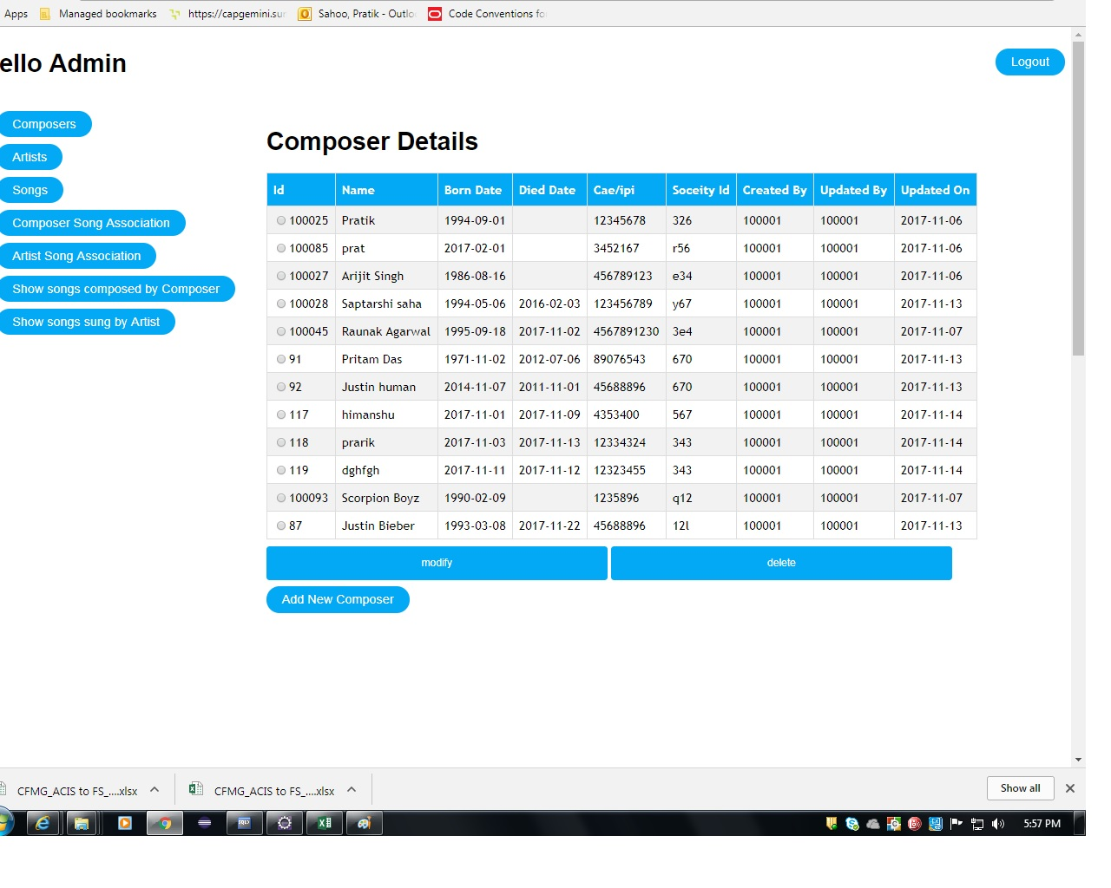

List Of Design Classes

Sr. No. | LLD Name | Class Name | Method Name | Method Description
1 | Delete Module | ComposerMasterDTO | Appropriate getters and setters methods | Getters retrieve the property values and setters set the property values
2 | Delete Module | MediaController | modifyAndDeleteComposer(@RequestParam("submit") String submit, @RequestParam("composerId") String composerId, @ModelAttribute("composerMasterDTO") ComposerMasterDTO composerMasterDTO, Model model): String | Sets the model attribute.  Calls getComposerById (composerId) of MediaServiceImpl class. It basically selects an existing composer as composer object and sets it into session , then it redirects to delete the composer else in case of exception redirects to error page with appropriate error message.  Calls deleteComposer(ComposerMasterDTO composerMasterDTO) of MediaServiceImpl class. It deletes the composer details else it redirects to error page with appropriate error message.  Calls loadAllComposers(ComposerMasterDTO composerMasterDTO) to show the updated composer list.
3 | Delete Module | MediaServiceImpl | getComposerById(int composerId):ComposerMasterDTO  deleteComposer(ComposerMasterDTO composerMasterDTO): ComposerMasterDTO | Calls getComposerById(int) of MediaDAOImpl class and returns the result to controller.  Calls deleteComposer ( ComposerMasterDTO ) of MediaDAOImpl class and returns the result to controller.

4 | Delete Module | MediaDAOImpl | getComposerById(int composerId):ComposerMasterDTO  deleteComposer(ComposerMasterDTO composerMasterDTO): ComposerMasterDTO | Gets the details of the desired composer depending upon the composer Id from database and returns the result to MediaServiceImpl.  Delete the desired composer into the database updating the composer list at the same time and returns result to MediaServiceImpl .

Re-Usable Routines/Components

Re-Usable Routines/Components

- CSS files
- Javascript files
- DataAccessException class
- Database properties files
- Logger properties files

Messages

No messages to display.

Configuration Files

File Name | Path | Description
oracle.properties | /Development/Source | To configure database connection.
Web.xml | /Development/Source | To configure the bean properties.
Dispatcher-servlet.xml | /Development/Source | To configure the request mapping and view resolver.
logger.properties | /Development/Source | To configure the logger.
error.properties | /Development/Source | To configure error messages.
JPAContext.xml | /Development/Source | To configure the datasource, entity manager factory and transaction manager.

Crud Matrix Table

# | Table Name | Create | Read | Update | Delete
1 | Composer_Master | N | Y | N | Y

Data Mapping Matrix

Sr. No. | Screen Label | Field Source | Field Type | Data Type | Max Length | Data Flow | Mandatory
1 | Composer Name | NA | Label | NA | NA | UI | NA
2 | composerName | ComposerMasterDTO.  Composer_Name | TextBox | Varchar2 | 50 | UI→D | Yes
3 | Composer Born Date | NA | Label | NA | NA | UI | NA
4 | composerBornDate | ComposerMasterDTO. Composer_BornDate | Date | Date | NA | UI→D | Yes
5 | Composer Died Date | NA | Label | NA | NA | D→UI | NA
6 | composerDiedDate | ComposerMasterDTO. Composer_DiedDate | Date | Date | NA | UI→D | Yes
7 | Composer Caeipi Number | NA | Label | NA | NA | UI | NA
8 | composerCaeipiNumber | ComposerMasterDTO. CaeipiNumber | TextBox | Varchar2 | 10 | UI→D | Yes
9 | Composer Music Id | NA | Label | NA | NA | UI | NA
10 | composerMusicSocId | ComposerMasterDTO. MusicSocietyId | TextBox | Char | 3 | UI→D | Yes
11 | Delete Composer | NA | Submit | NA | NA | UI | NA

Legend
D → UI (Database to User Interface)
UI → D (User Interface to Database)
UI (User Interface Only)

Action Flow Matrix

Sr. No. | Action | Description | Process
1 | On click of  ‘Delete’ Button | The composer along with the details is deleted and the admin is notified of the deletion. | On clicking delete composer button, the composer details are deleted from the database and the success message is displayed.

Stored Procedures

# | Stored Procedure Name  (with Description) | Input/Out Parameters | Type | Size
1. | NA | NA | NA | NA

Program Specification / Pseudo Code

14.1 <ACTION: SEARCH_CLICK>

Pseudo Code:
- Client Side Scripting:
None
- Server Side Scripting:
BEGIN
Call modifyAndDeleteComposer(@RequestParam("submit") String submit, @RequestParam("composerId") String composerId,@ModelAttribute("composerMasterDTO") ComposerMasterDTO composerMasterDTO, Model model) in Controller class
BEGIN
Call getComposerById() from MediaServiceInterface of service layer
Call deleteComposer() from MediaServiceInterface of service layer
Call loadAllComposer()from MediaServiceInterface of service layer

BEGIN
Call getComposerById() in MediaDAOInterface of dao layer.
Call deleteComposer() from MediaDAOInterface of dao layer.
Call loadAllComposer()from MediaDAOInterface of dao layer.

BEGIN
Create query for deleting details from Composer_Master table
Return composer details and returns a list
END
Return composer details and returns a list to Service Layer
END
Return composer details and returns a list to Presentation Layer
END
REVISION HISTORY OF THE WORK PRODUCT

# | Date | Version # | Section Changed | Details of changes made | Approved By
1 | 13/11/2017 | 1.0 | LLD prepared | N/A | Vishal Mali
2 | 05/11/2017 | 1.1 | Reusable components,  Pseudo code | Reusable components added.  The pseudo code is modified as per the specified flow. | Vishal Mali
3 | 08/11/2017 | 1.2 | Reusable components,  References,  Data Mapping Matrix. | Reusable Components added.  File name with relative path is added in the references section.  The name of text boxes(screen label is changed). | Vishal Mali
4 | 09/11/2017 | 1.3 | Configuration files,UI Components | Paths of the configuration files is updated and UI components(Screen Shots) added. | Vishal Mali

